Name: NGO TUNG CHUONG
ID: s225586848

Based on the mechanic behind the spread of the infections.
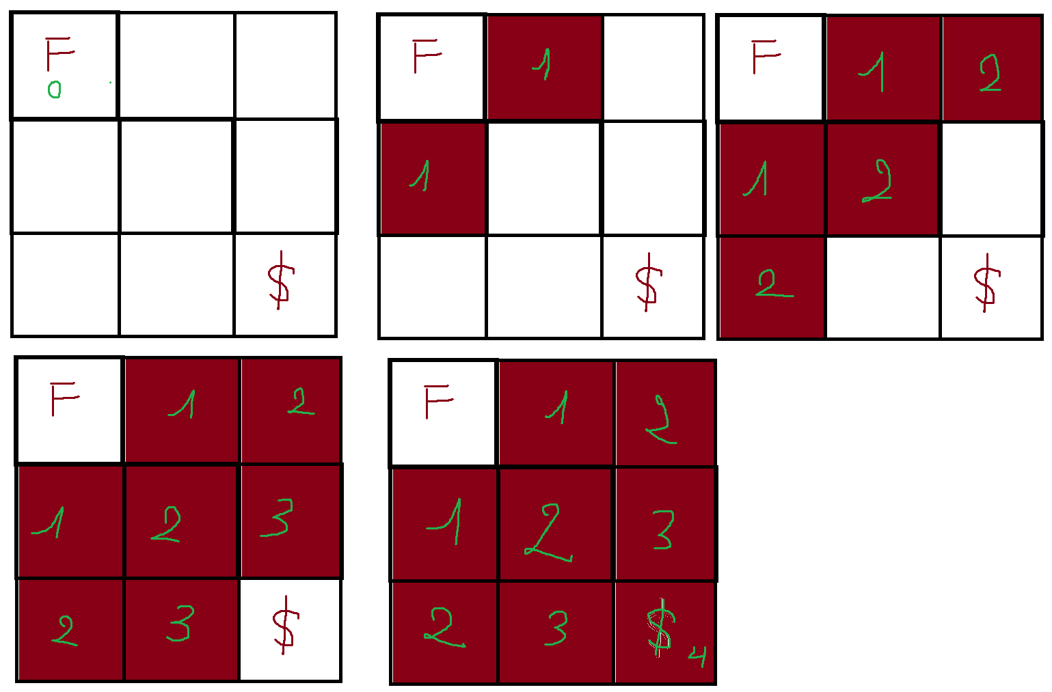
I noted that with each adjacent tiles next to infected it get infected to. Which similar to FIFO(First In First Out) principle when you check infected tile first then the next infected tiles. With each infected tiles, I gave its with the time mark to know when the tiles got infected.
Same goes with the player (I called in this simulation). Each adjacent tiles allow the possible for the player to move to. But in this case, each time “spread”, the condition to make sure that player only land on: First, player arrive before infected and second, player can stand on that tile safely (infinity). Those are the two basic fundamental backbone of my coding logic.

Pseudocode: (relax case – no wall in process)
While (infectedQueue != null) {
adjacentTile.updateInfectedTime();
infectedQueue.enqueue(adjacentTile);
}
While (playerQueue != null){
If (adjacentTile.infectedTime < playerSurviveTime}
playerSurviveTime++;
playerQueue.enqueue(adjacentTile);
}
If (adjacentTile.notInfected()) {
player.Stand();
break;
}
}

Return player.longestSurviveTime() -> -1 if infinity

